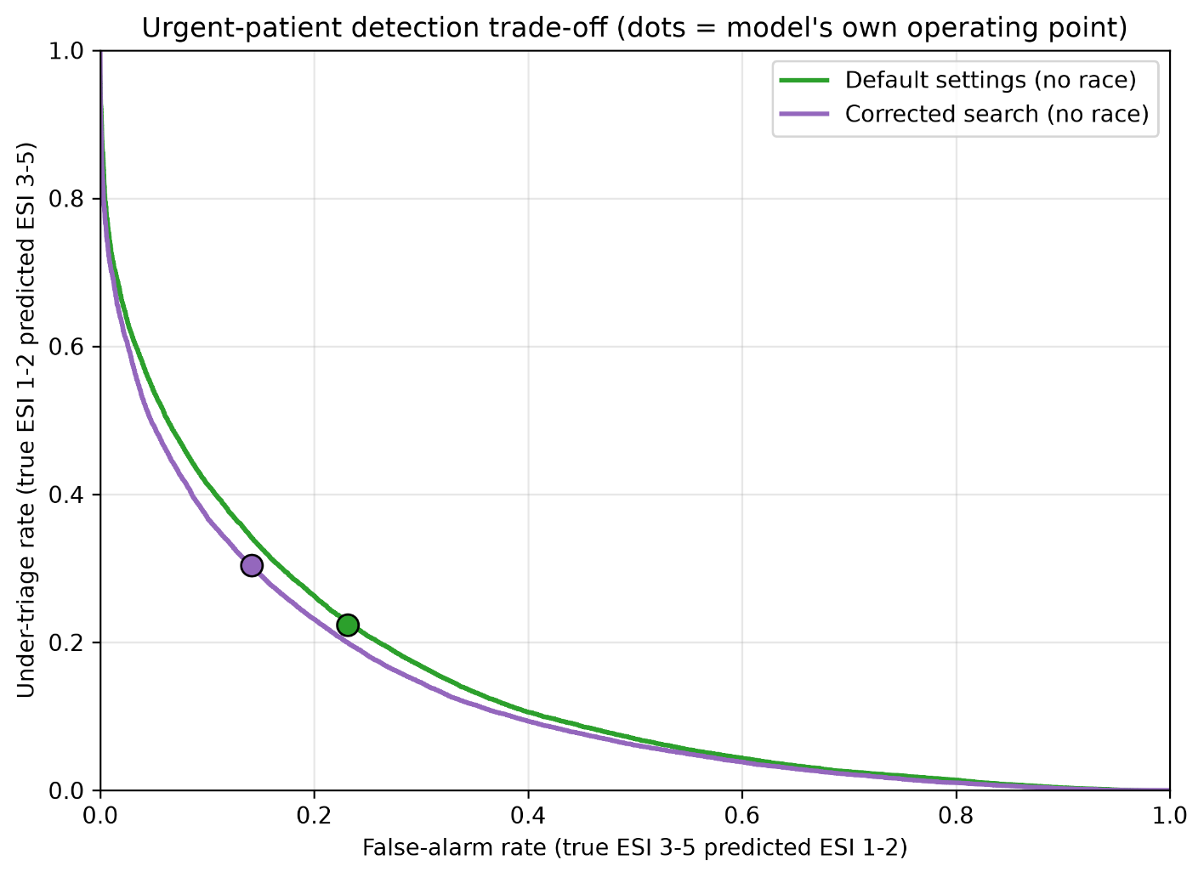
Figure: figure_operating_points.png
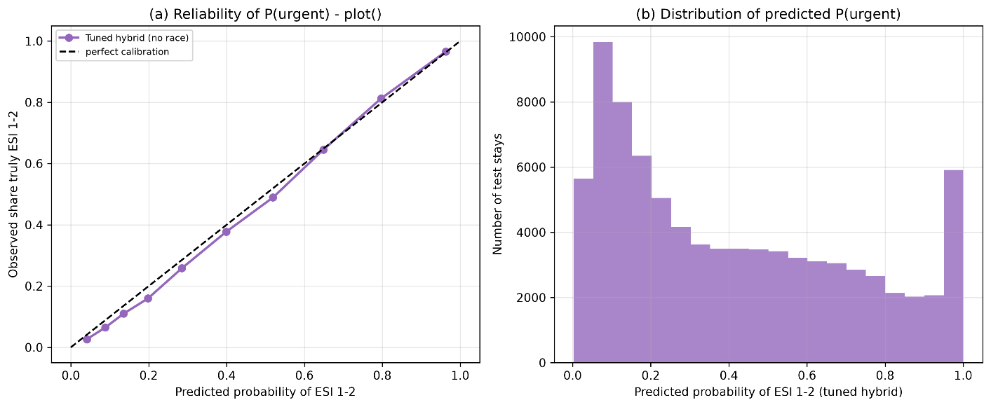
Figure: figure_calibration.png
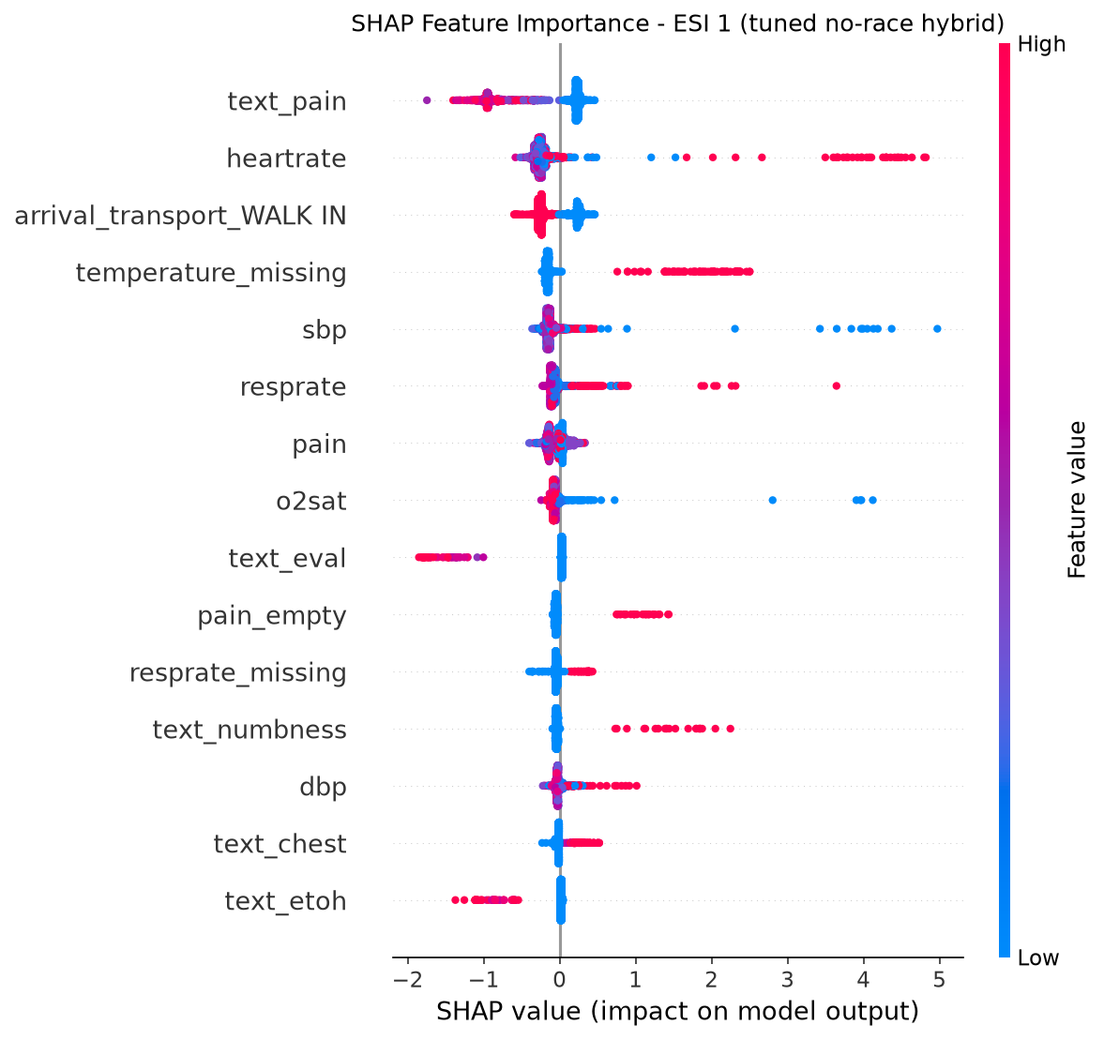
Figure: shap_esi1_tuned_norace.png
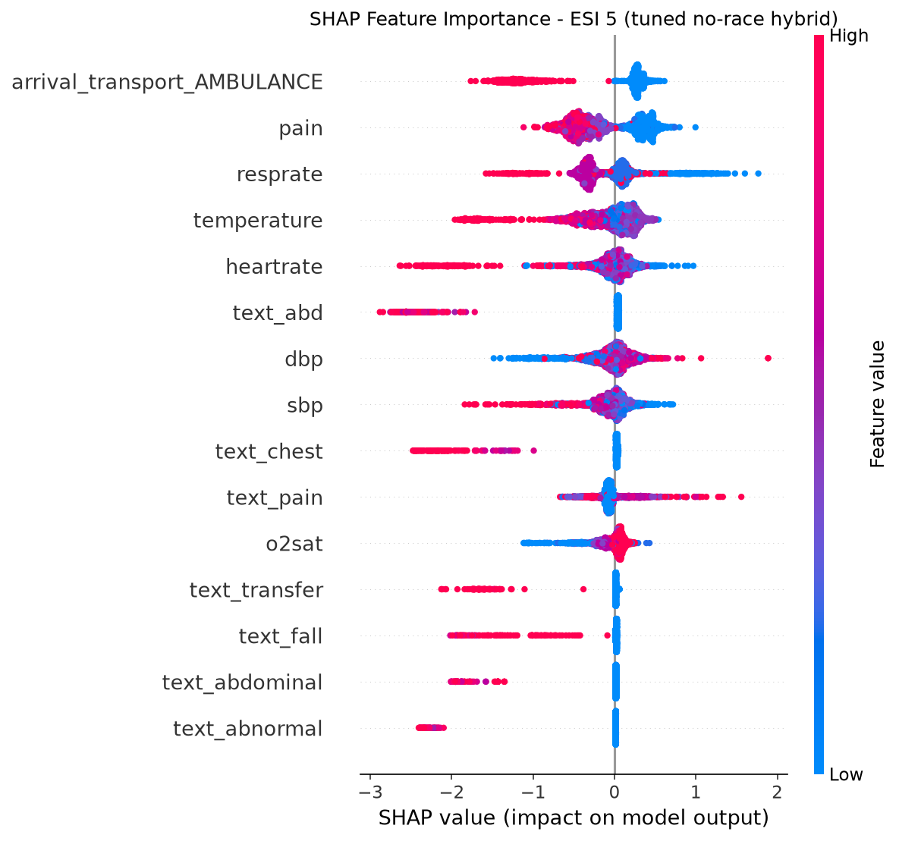
Fig: shap_esi5_tuned_norace.png

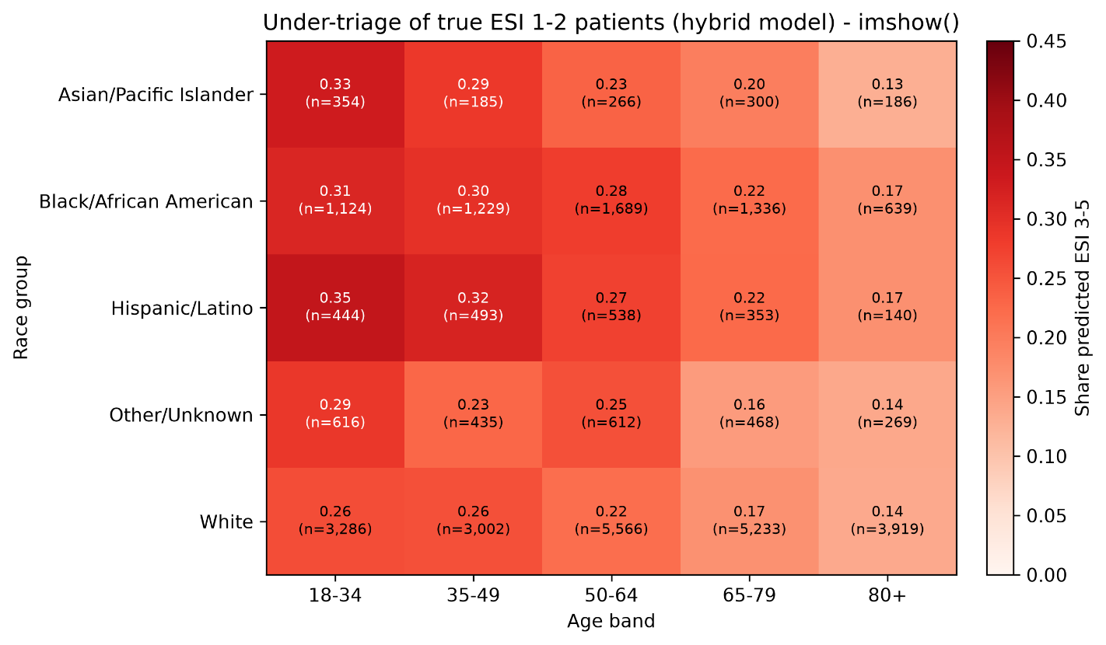
Figure: Figure_equity_heatmap_Hybrid_C.png

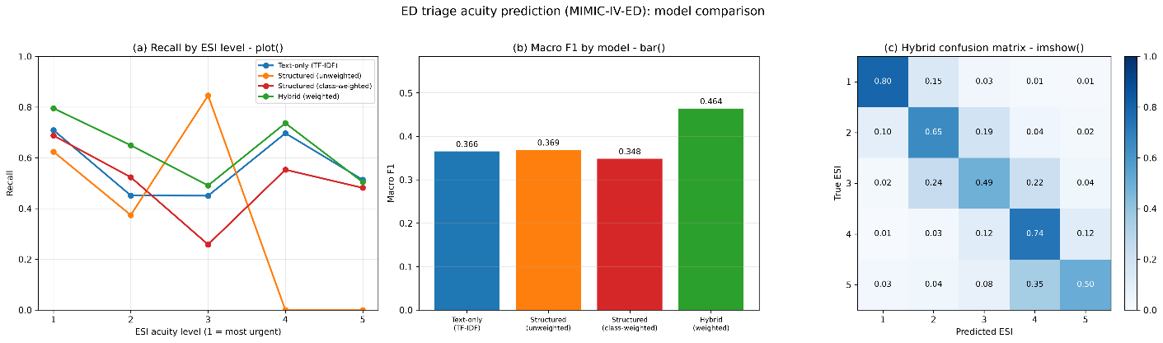
Figure: Figure_Hybrid_Model_C.png

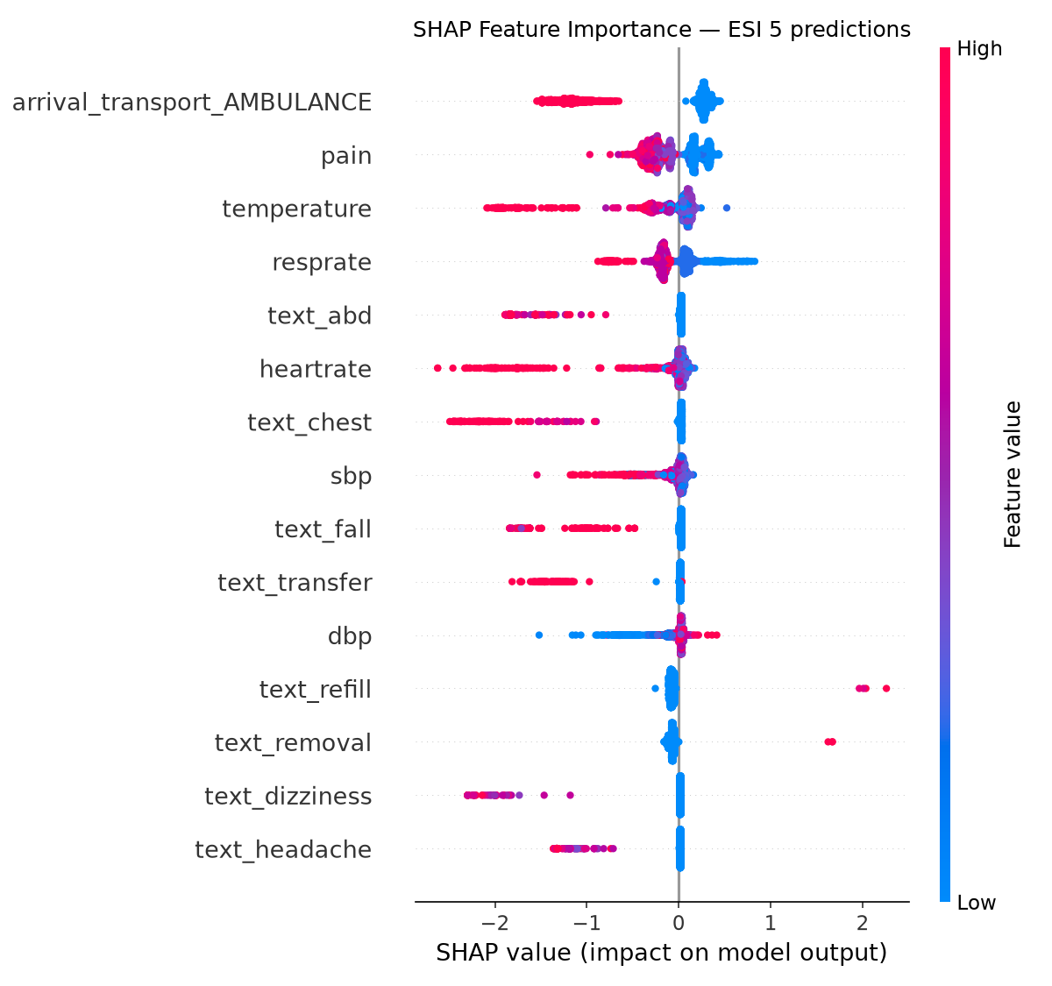
Figure: shap_esi5.png
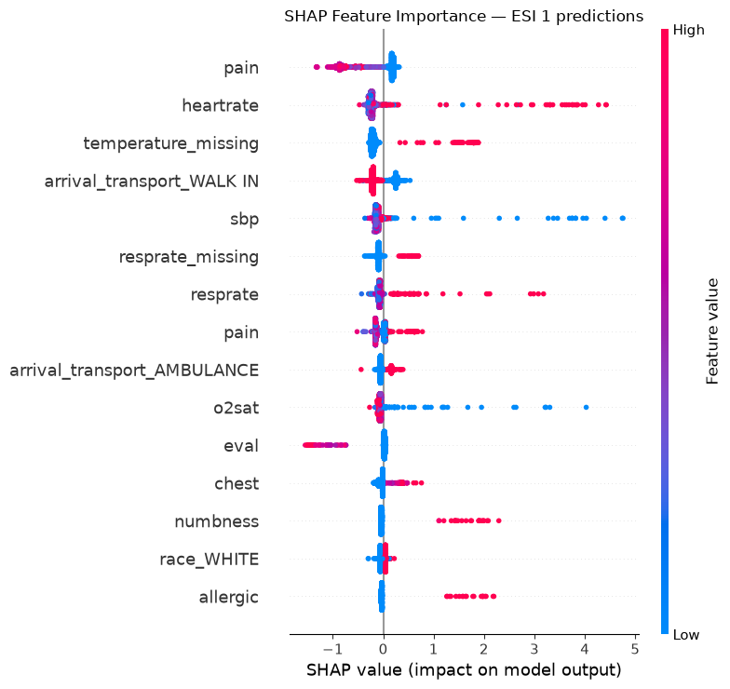
Figure: shap_esi1.png

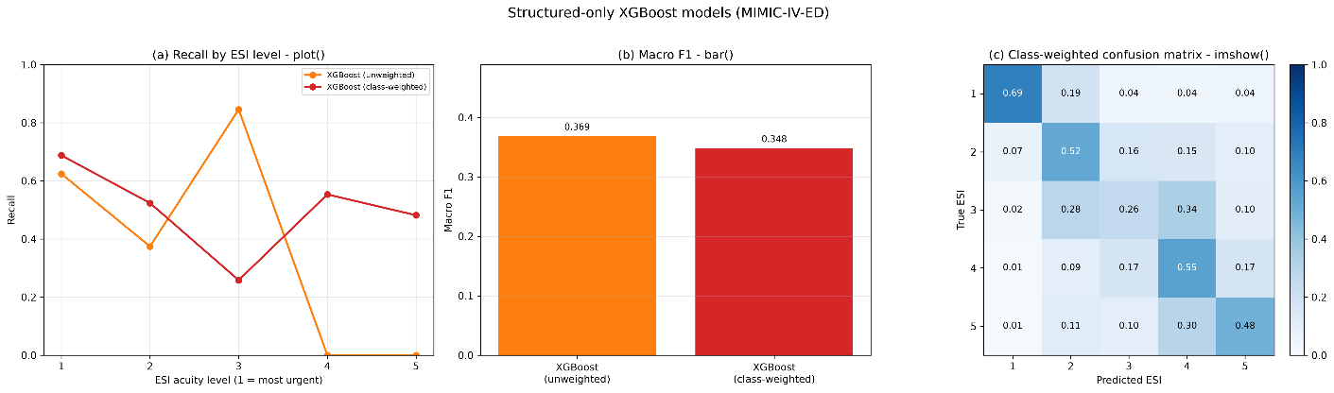
Figure: Figure_Structured_Model_B.png

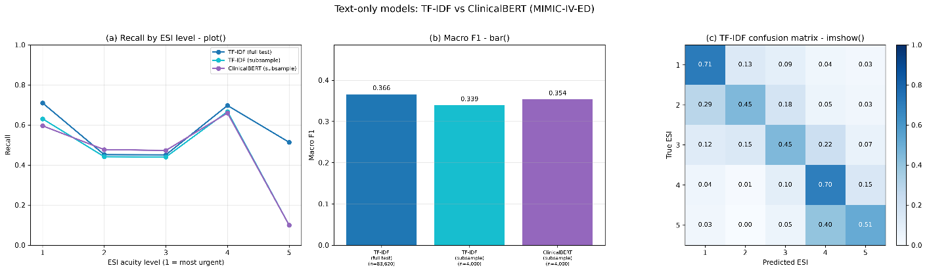
Figure: Figure_Text_Model_A.png

